Observer design pattern.

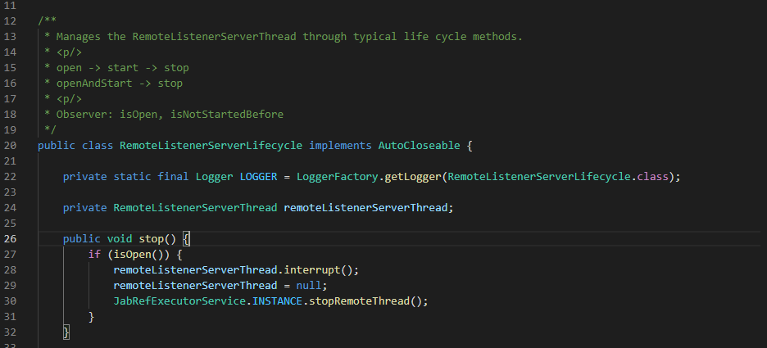

This class can be found in src\main\java\org\jabref\logic\remote\server\RemoteListenerServerLifecycle.java.

It is an event manager which manages listeners of RemoteListenerServerThread type.

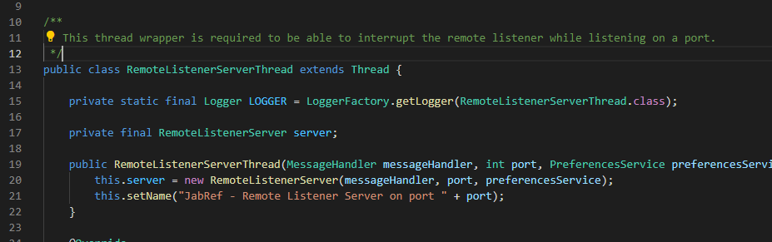

This class is implements in src\main\java\org\jabref\logic\remote\server\RemoteListenerServerThread.java, this in turn calls a Remote Listener server which has the listeners.

